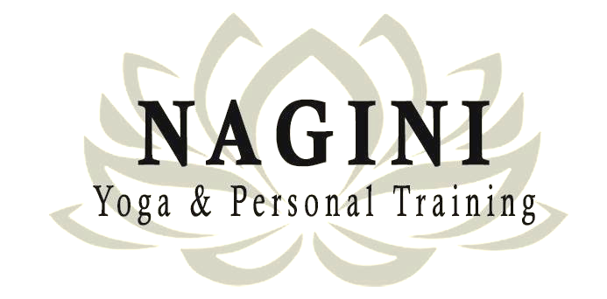

**Calling all fitness enthusiasts in the Reading West area!**

Are you ready to transform your body and mind? We're excited to offer you

a unique opportunity to experience the best Pilates and Yoga classes, tailored to

enhance your flexibility, strength, and balance. Try our Pilates or Yoga class

and discover a new way to energize your body.

**Special Deal:**

Use the promo code **PG03** to enjoy a **Two for One Offer!** Bring a friend along, and both of you can enjoy two classes for the price of one. Valid for 31/03/2025.

## **Why Choose Us?**

* Welcoming Environment: Our studio is designed to make you feel comfortable and supported throughout your journey. *Fitness4Women, 90 Audley St, Reading RG30 1BS*
* Only £10 per Class

| **Pilates** | **Yoga** | **Step-by-step instructions to claim your promo code:**   1. Scan the QR Code for attending Pilates or Yoga 2. Book Your First Two Sessions 3. Write Your Promo Code   In the comment section of the booking form, enter the promo code GP03. This will activate your limited first-time offer.   1. Pay for Your Classes   After booking, you will receive an email with instructions on how to complete the payment via bank transfer.   1. Enjoy Your Classes |
| --- | --- | --- |
|  |  |



**Calling all fitness enthusiasts in the Reading West area!**

Are you ready to transform your body and mind? We're excited to offer you

a unique opportunity to experience the best Pilates and Yoga classes, tailored to

enhance your flexibility, strength, and balance. Try our Pilates or Yoga class

and discover a new way to energize your body.

**Special Deal:**

Use the promo code **PG03** to enjoy a **Two for One Offer!** Bring a friend along, and both of you can enjoy two classes for the price of one. Valid for 31/03/2025.

## **Why Choose Us?**

* Welcoming Environment: Our studio is designed to make you feel comfortable and supported throughout your journey. *Fitness4Women, 90 Audley St, Reading RG30 1BS*
* Only £10 per Class

| **Pilates** | **Yoga** | **Step-by-step instructions to claim your promo code:**   1. Scan the QR Code for attending Pilates or Yoga 2. Book Your First Two Sessions 3. Write Your Promo Code   In the comment section of the booking form, enter the promo code GP03. This will activate your limited first-time offer.   1. Pay for Your Classes   After booking, you will receive an email with instructions on how to complete the payment via bank transfer.   1. Enjoy Your Classes |
| --- | --- | --- |
|  |  |